Chapter 17, Solution 76.

v_{s}(t) is the same as f(t) in Figure 16.1 except that the magnitude is multiplied by 10. Hence

v_{o}(t) = 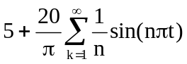, n = 2k – 1

T = 2, ω_{o} = 2π/T = 2π, ω_{n} = nω_{o} = 2nπ

jω_{n}L = j2nπ; Z = R||10 = 10R/(10 + R)

V_{o} = ZV_{s}/(Z + j2nπ) = [10R/(10R + j2nπ(10 + R))]V_{s}

V_{o} = 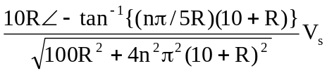

V_{s} = [20/(nπ)]∠0°

The source current I_{s} is

I_{s} = 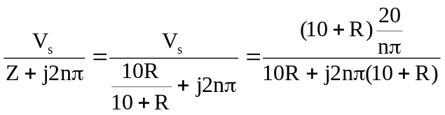

= 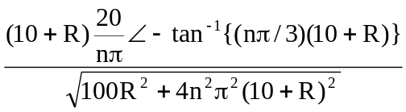

p_{s} = V_{DC}I_{DC} + 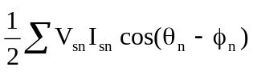

For the DC case, L acts like a short-circuit.

I_{s} = 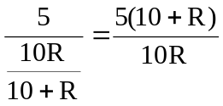, V_{s} = 5 = V_{o}

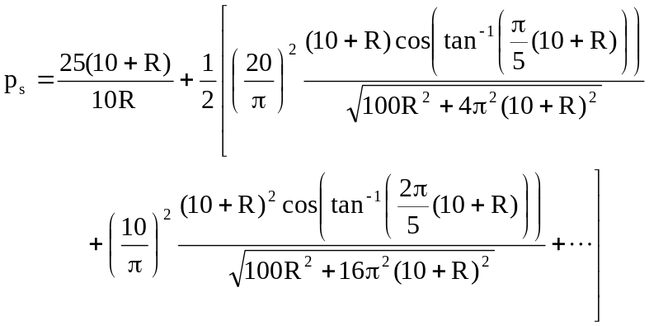

p_{s} = 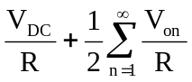

= 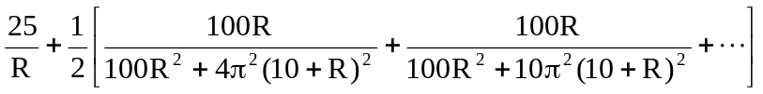

We want p_{o} = (70/100)p_{s} = 0.7p_{s}. Due to the complexity of the terms, we consider only the DC component as an approximation. In fact the DC component has the latgest share of the power for both input and output signals.

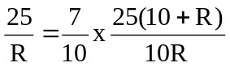

100 = 70 + 7R which leads to R = 30/7 = 4.286 Ω

